**Talk with Your Data Workshop - Installation Guide**

**Installation Steps**

1.) **Install Conda**

* Option 1: Miniconda (lightweight option) - [Download Here](https://www.anaconda.com/download)
* Option 2: Anaconda (includes more tools) - [Download Here](https://www.anaconda.com/download)
* Option 3: Alternatively, you can install Python directly, but this won’t have the dependencies preloaded.

[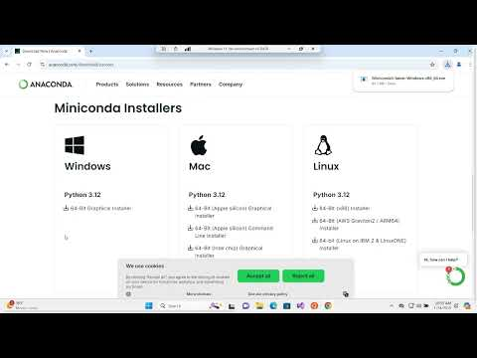](https://www.youtube.com/embed/wwKAFw2Dwz0?feature=oembed)

<https://www.youtube.com/watch?v=wwKAFw2Dwz0>

2.) **Install Cursor**

* Download and install Cursor from [here](https://www.cursor.com/)
* Note: You will need to create a free account.

[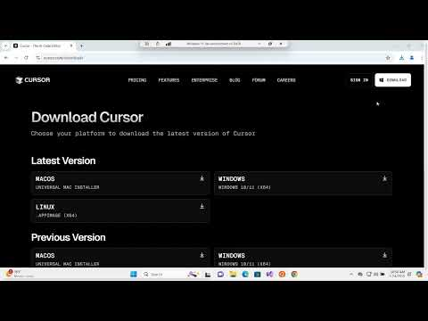](https://www.youtube.com/embed/L_A2P1KJYpw?feature=oembed)

<https://www.youtube.com/watch?v=L_A2P1KJYpw>

3.) **Download the GitHub files, unzip, and set up the Conda environment**

* Download the necessary files from [GitHub](https://bit.ly/4ibI6X7)

<https://bit.ly/4ibI6X7>

* Steps: a.) Download the zip file b.) Extract the zip file c.) Open Anaconda Prompt d.) In the Conda prompt, navigate to the directory with the GitHub files:
* In a conda prompt type (update to the directory with the Github files):

cd <*directory with files*>

conda env create -f environment.yml

conda activate workshop_env

* Run the Python file that will install the LLM for this project:

Windows (Command Prompt or Anaconda Prompt)

cd <*directory with files*>

python LLM.py

python -c "import sqlite3; print(sqlite3.sqlite_version)"

python -c "import huggingface_hub; print('Hugging Face Hub works!')"

[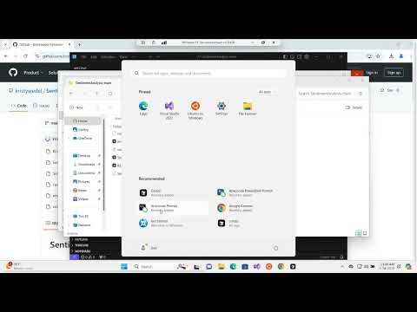](https://www.youtube.com/embed/Fv_tDvJuJpk?feature=oembed)<https://www.youtube.com/watch?v=Fv_tDvJuJpk>

4.) **Set up Cursor with Conda by testing a prompt**

* Open Cursor and log in.
* Navigate to the folder containing the downloaded files.
* Open the chat using **Ctrl + L** and enter the following prompt:

Create an app.py file that says “Hello World.”

* After the code is generated, scroll to the code section and press the **Apply** button.
* Click **Select Kernel**.
* Install Python and Jupyter extensions (a status bar will appear in the lower-left corner indicating installation progress).
* After installation, click **Python Environments** and select workshop_env.
* Click the **Play** button to run the notebook.

5.) **Set up the Python Interpreter**

* Open the **Command Palette** (**Ctrl+Shift+P**), type Python: Select Interpreter, and choose the appropriate Python version.